Word Search

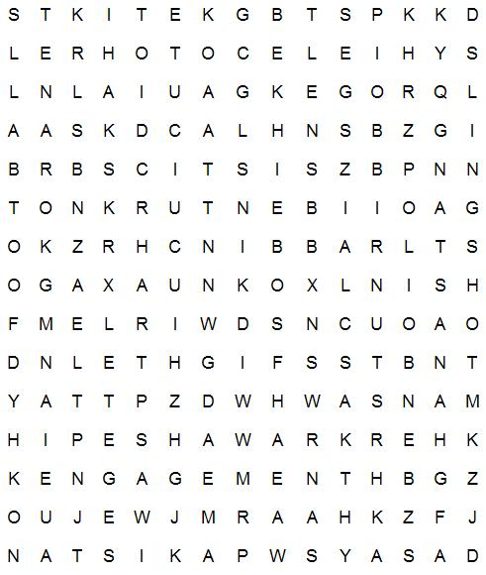

AFGHANASTAN | ALLAH | BRASSKNUCKLES
ENGAGEMENT | FIGHT | FOOTBALL
HOSSEINI | KABUL | KITE
KITERUNNING | KORAN | MARRIAGE
PAKISTAN | PESHAWAR | POLIO
SHEEP | SLINGSHOT | TALIBAN
TRADITIONS

